This set of codes provide a complementary version of “Automontaging”. “Automontaging” successfully places sumNorms[[1]](#footnote-1) obtained from different AOSLO videos in right place. However, the borders are visible (Figure *1*). “Automerging” helps to remove these visible borders and obtain a smooth montage.

C:\Users\Asus\Downloads\all_ref_combined_m1.tif

Figure 1- how the output of “Automontaging” looks like.

Using “Automerging” is easy. You just need to run “Automerging.m” and instructions will be shown on MATLAB workspace. There is no need to run “Automontaging” again, if you have done it before; you just need to give the path to the folder containing the results of “Automontaging” when asked by “Automerging”.

After automatic merging, you can easily change some parts of the merged image that don’t have enough quality.

The program asks users to locate the problematic parts by mouse. He/she must just click on one point that he/she thinks its surrounding area is not good enough.

An example is shown in Figure *2*.

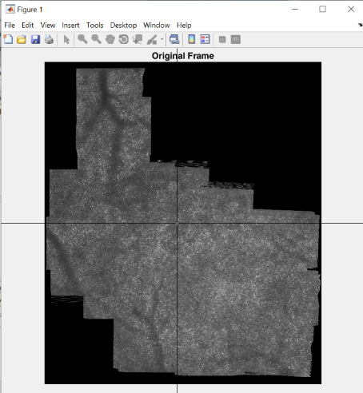

Figure 2- selecting a point to replace its surrounding area.

Then all the frames that are contributing to that point will be shown in different frames (Figure *3*). The user can choose one of these frames or keep the original frame (sometimes, maybe the present merged frame is better than the other alternatives).

For our selected point, there were five candidate frames (frames 25, 26, 27, 28, 39). Here I showed two of them (frame 26 in Figure *3*-left, and frame 28 in Figure *3*-right). The user must just enter the ‘Number’ that is written above the figure (not the frame number). Since in some cases only the corner of the candidate frame is placed around the selected point, it is difficult to find the target area. To help the user in these cases, a yellow rectangle is drawn around the candidate frames.

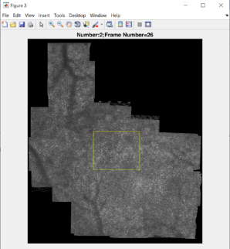 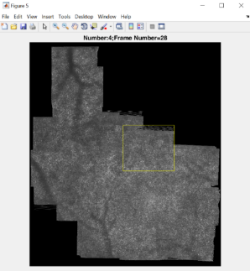

Figure 3-two of the candidate frames.

After choosing one of the candidate frames, user can keep it in the same way as it is, or select a part of that frame. In that case, a frame like Figure *4* will be shown. The user can zoom in the image and select a subpart of the overlapping area. Here I zoomed in the overlapping area (see Figure *4*-right).

 

Figure 4-overlay image of the automerged image and the selected candidate frame.

As can be seen, the central part of the chosen frame matches very well with the automerged image. So, I think we should choose that area (something like Figure *5*). This polygon can be in any shape that the user desires.

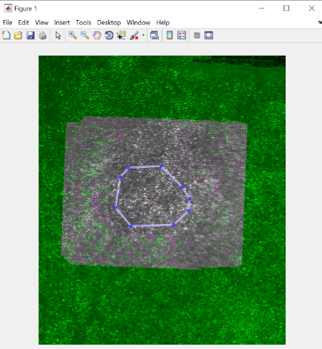

Figure 5- manual selection.

And here is the resulted final merged image.



Figure 6-our final merged image

This process can be repeated several times for different points of the image. Each run (with my computer that I think is slower than the computers available in the lab) takes just a few seconds.

\*\*\*

Sometimes there is huge difference between the intensity of the individual sumNorms, or even through different spots of one sumNorm. In those cases, the result of “Automerging” does not look good.

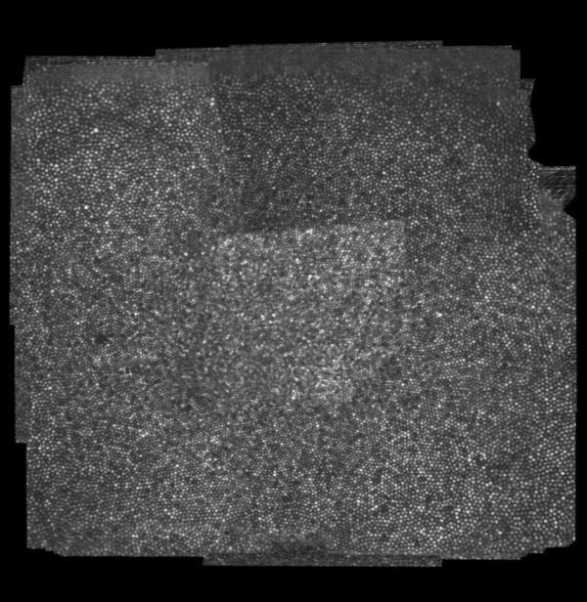

Figure 7- the result of “Automerging” without applying histogram correction (compare with Figure 1).

This problem can be solved by using some histogram correction algorithms. I tested several algorithms, but the best result can be obtained using “FieldCorrection\_SingleFrames.m”. This piece of code must be run after “Automontaging” and before “Automerging”. So, my suggestion is that if you aim to use it, first run “AUtomontaging”, then run “FieldCorrection\_SingleFrames.m” and then when running “Automerging” give the path to the folder containing the corrected sumNorms to the “Automerging”.

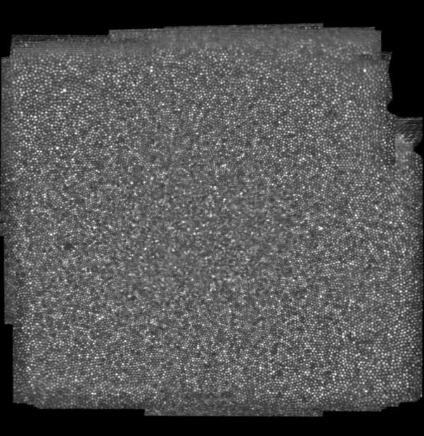

Figure 8- the result of “Automerging” with applying histogram correction (compare with Figure 1).

1. A sumNorm image is the mean of all the frames in an AOSLO video after stabilization. Since the natural FEM exists during AOSLO recording, sumNorm is always larger than a single frame, and does not have a clear rectangular shape. [↑](#footnote-ref-1)